**Effects of climate change**

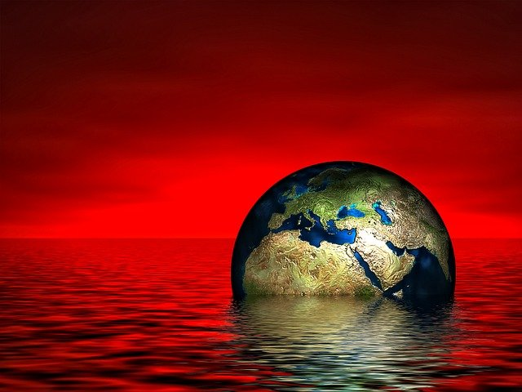The effects of climate change span the physical environment, ecosystems and human societies. It also includes the economic and social changes which stem from living in a warmer world. Human-caused climate change is one of the threats to sustainability.

Many physical impacts of climate change are already visible, including extreme weather events, glacier retreat, changes in the timing of seasonal events (e.g., earlier flowering of plants), sea level rise, and declines in Arctic sea ice extent. The ocean has taken up between 20–30% of human-induced atmospheric carbon dioxide since the 1980s, leading to ocean acidification. The ocean is also warming and since 1970 has absorbed more than 90% of the excess heat in the climate system.

Physical impacts

A broad range of evidence shows that the climate system has warmed. Increasing temperature over land and the ocean, and sea level rise. The decreased snow cover in the Northern Hemisphere, and declining Arctic sea ice, both of which are indicative of global warming. Evidence of warming is also apparent in living (biological) systems such as changes in distribution of flora and fauna towards the poles.

Human-induced warming could lead to large-scale, abrupt and/or irreversible changes in physical systems. An example of this is the melting of ice sheets, which contributes to sea level rise and will continue for thousands of years. The probability of warming having unforeseen consequences increases with the rate, magnitude, and duration of climate change.

Wildlife and nature

Recent warming has strongly affected natural biological systems. Species worldwide are moving poleward to colder areas. On land, species move to higher elevations, whereas marine species find colder water at greater depths. Of the drivers with the biggest global impact on nature, climate change ranks third over the five decades before 2020, with only change in land use and sea use, and direct exploitation of organisms having a greater impact.

Regional effects

Regional effects of global warming vary in nature. Some are the result of a generalised global change, such as rising temperature, resulting in local effects, such as melting ice. In other cases, a change may be related to a change in a particular ocean current or weather system. In such cases, the regional effect may be disproportionate and will not necessarily follow the global trend.

There are three major ways in which global warming will make changes to regional climate: melting or forming ice, changing the hydrological cycle (of evaporation and precipitation) and changing currents in the oceans and air flows in the atmosphere. The coast can also be considered a region, and will suffer severe impacts from sea level rise.

On humans

The effects of climate change, in combination with the sustained increases in greenhouse gas emissions, have led scientists to characterize it as a climate emergency.It is an existential threat to civilization. Some areas may become too hot for humans to live in while people in some areas may experience displacement triggered by flooding and other climate change related disasters. The quality and quantity of freshwater will likely be affected almost everywhere. Some people may be particularly at risk from climate change, such as the poor, young children and the elderly. According to the World Health Organization, between 2030 and 2050, "climate change is expected to cause about 250,000 additional deaths per year." As global temperatures increase, so does the number of heat stress, heatstroke, and cardiovascular and kidney disease deaths and illnesses. When air pollution worsens, so does respiratory health, particularly for the 300 million people worldwide living with asthma; there is more airborne pollen and mold to torment hay fever and allergy sufferers.